

9B19M027

NORLHA: SCALING UP SUSTAINABLE LUXURY ON THE TIBETAN PLATEAU

Haitao Yu and Diane-Laure Arjaliès wrote this case solely to provide material for class discussion. The authors do not intend to illustrate either effective or ineffective handling of a managerial situation. The authors may have disguised certain names and other identifying information to protect confidentiality.

This publication may not be transmitted, photocopied, digitized, or otherwise reproduced in any form or by any means without the permission of the copyright holder. Reproduction of this material is not covered under authorization by any reproduction rights organization. To order copies or request permission to reproduce materials, contact Ivey Publishing, Ivey Business School, Western University, London, Ontario, Canada, N6G 0N1; (t) 519.661.3208; (e) cases@ivey.ca; www.iveycases.com. Our goal is to publish materials of the highest quality; submit any errata to publishcases@ivey.ca. i1v2e5y5pubs

Copyright © 2019, Ivey Business School Foundation Version: 2019-04-12

When I was a child experiencing a nomadic life, I really aspired to have a city life. I thought urban people lived better than us. But this idea was an illusion, based on what television conveyed. Since I started working at Norlha, I have been fortunate enough to travel to big cities. I realized that urban life was not as good as I imagined. At Norlha, we have built an environment with good living conditions and nice people. I enjoy my village life and its peaceful moments. I have realized that the environment can be improved through hard work on our own lands.

Dorjee, a nomad turned sales manager at Norlha Textiles

On July 15, 2015, Dechen Yeshi, the chief executive officer (CEO) of Norlha Textiles (Norlha) was wondering how she could grow the company to increase its positive impact on the Tibetan Plateau. Located in Ritoma, a remote village situated in the Gannan Tibetan Autonomous Prefecture in West China, Norlha designed, produced, and sold luxury yak wool textiles made by nomads. Dechen hoped that Norlha would be the first of many companies to provide Tibetan nomads with an opportunity to have a decent life on the changing Tibetan Plateau. She wanted to scale up the model, but to do so required a partnership since Norlha was constrained by its financial needs. Recently, the Bureau of Commerce of the prefecture had asked Norlha to expand its model to Choni County, a nearby nomadic county. The bureau’s invitation offered a good opportunity to expand Norlha’s footprint. Yet Dechen hesitated. Agreeing to collaborate would be similar to entering into a marriage: She needed to be very careful. Should Norlha partner with the bureau to replicate its model in Choni County? If so, how should Norlha proceed?

THE CONTEXT: the CHANGING TIBETAN PLATEAU

The Tibetan Plateau was one of the most remote and fragile environments on the planet.[1] The average altitude was 4,500 metres above sea level, and the total area was approximately 2.5 million square kilometres. The Tibetan Plateau had long arctic winters and short warm summers. For more than 3,000 years, nomads had lived with their herds of yaks and sheep on the pastoral grassland, in harmony with their natural environment.[2] Twice a year, the nomads would relocate and rotate the pastures. This nomadic life helped them adapt to the seasons and enabled the grass to regrow for the following year’s grazing. Aware of the fragility of the ecosystem and to maintain the equilibrium of the community, nomads also had strict rules that limited the number of herds for each family. However, this traditional way of life had progressively disappeared

At the beginning of the 2000s, many young nomads began leaving their pastures to populate cities on the Tibetan Plateau and in the rest of China. Tibetan youth who started to go to schools in cities began to aspire to a more modern way of life. They hoped to acquire the apartments, cars, and electronics they saw on television and in magazines. Yet due to their limited Mandarin skills, education and their cultural background, which differed from that of the Han,[3] most of the young nomads were unable to find employment in urban centres. Meanwhile, most of the nomadic families who decided to stay on the grasslands had increased the size of their herds to generate more cash, breaking a rule that had lasted for centuries. Pastures became less lush due to overgrazing. More frequent drought, due to climate change, worsened the grassland degradation, threatening the long-term feasibility of herding.

In such a short period, the old way of life collided with modernity without any buffer. Many nomadic youths were lost between the modern and nomadic worlds. To explore alternative livelihoods for the Tibetan nomads in their rural homes, Dechen, who was half Tibetan and half American, went to the Tibetan Plateau in 2004. She had just graduated from Connecticut College in the United States where she had majored in Asian studies and film. Dechen had never lived on the Tibetan Plateau, but believed she could do something good for the Tibetan nomads by transforming the production of yak wool into a business.

**NORLHA TEXTILES: SUSTAINABLE LUXURY ON THE TIBETAN PLATEAU**

The Origins of Norlha

In the 1980s, the Chinese government had attempted to exploit yak wool to create an industry.[4] However, the market had almost disappeared during the 1990s due to low profitability. The idea of utilizing yak wool to craft luxury products came from Dechen’s mother, Kim Yeshi, a French-American woman who had moved to India after meeting her Tibetan husband at a U.S. college. Kim had more than 25 years of experience in managing workshops producing high-quality textiles and handcrafts in Asia. Both an anthropologist and a Tibetan Buddhist, Kim had always dreamed of creating something beneficial for the Tibetans.

Dechen inherited Kim’s yak dream. In 2004, Dechen went to Ritoma, a village that her mother suggested she visit, and immediately fell in love with the place. One year later, she returned and successfully convinced two male and two female nomads to pilot a yak wool–weaving project. In 2006, Dechen led her team to Cambodia and Nepal to learn about textile weaving and textile management processes. On their return to Ritoma in the summer of 2007, Norlha was born. In Tibetan, *nor* meant wealth, but it was also the term nomads used to refer to the yaks from which they gain their livelihood, including meat, milk, fur, wool, and dung for fuel. Norlha opted for a for-profit legal form of business since doing business was well understood and accepted in China. Dechen became the CEO of Norlha, and Kim served as the president. The same year, the permanent Norlha workshop was built in Ritoma in a traditional Tibetan style (see Exhibit 1). Norlha’s core was the mother–daughter team working hand in hand; Dechen built her local team single-handedly, while Kim travelled constantly between Beijing, Shanghai, New York, and Paris, minding the customers, attracting financial backing, and navigating the road ahead

The Business Model of Norlha

The dominant model in the textile industry was to keep up with consumers’ fast-paced demands, while coordinating supply chains in the developing world through a central node that owned the brand name. Norlha, however, was different. Firstly, the company was based on a vertically integrated model. That is, Norlha was responsible for all business activities, including designing, producing, and selling textile products. Only a few luxury textile enterprises in France and Italy continued to operate this way. Secondly, Norlha borrowed from the European tradition of luxury houses the deep connection to the *terroir*.[5]

Value Proposition

Norlha’s added value for the luxury market came from the high-quality raw material it used to craft its products: yaks’ fine undercoat. Known in Tibetan as *khullu*, the undercoat wool fell from the yaks at the end of each winter. Although khullu was extremely soft and insulated, no one had used yak’s khullu to make fine textiles due to the technical constraints linked to their very short fibres. Norlha was also unique since it was situated in an inimitable geographical place: the Tibetan Plateau. The design of the products was inspired by the landscapes of the Tibetan Plateau. In the fall of 2007, Kim and Dechen took a picture of a Norlha blanket with one of the weavers sitting on a yak in the grey autumn pasture. They suddenly realized that this image was what Norlha represented—a community-based business. The brand image of Norlha was born. From then on, Norlha’s products would be showcased only in their natural environment, with the people and animals that helped create them (see Exhibit 2). Yang Guizhi, an executive who had more than 30 years’ experience working with cashmere, commented on Norlha’s attractiveness to customers:

Norlha is able to propose the right value in the right market. They have good quality products, but that’s not enough. They also have an integrated story. When people buy a Norlha scarf, they not only enjoy the extreme warmth and softness of the product but also feel warm and soft in their heart by contributing to the good cause on the Tibetan Plateau.[6]

Operations

Every summer, Norlha would send its employees to nomadic camps around Ritoma and nearby counties to purchase yak wool from the nomads. The company then washed the wool at workshops in a city bordering the Tibetan Plateau. Norlha sourced only the best khullu, which came from two-year-old yaks. After being washed, only about 20 per cent of the raw material remained. Local nomads in the Ritoma workshop then crafted the cleaned material through a process of spinning, weaving, felting, and tailoring (see Exhibit 3). In 2014, as the business became more complex, Norlha, aided by an Australian friend, implemented an enterprise resource planning (ERP) system. The ERP system helped Norlha better manage its production system, by providing its employees with real-time data (available on their tablets and notebooks) on the supply of materials, inventory, production quantities, and sales.

Norlha’s business model was very costly, particularly when compared with that of conventional textile companies in China. Norlha paid salaries that were 66 per cent higher than the average urban wage in the region (see Exhibit 4) in an effort to enable the retention of employees who had been trained (sometimes for years) on very specific skill sets. Also, being isolated on the Tibetan Plateau, Norlha needed to make large investments in building infrastructure to offer basic facilities such as electricity.

Distribution Channels

In 2008, Norlha started to penetrate the luxury market with its one-of-a-kind image. Norlha’s success resulted from its ability to combine a well-trained and diligent local workforce with a rare and high-quality product. Luxury brands such as Hermès valued the uniqueness of the company, the quality of the textile, and its authenticity. The story and *savoir-faire*, or know-how, of Norlha sold well. To gain access to the Chinese market, Norlha opened its first local showroom in 2010 at Labrang, a tourist town in China named for the Labrang Monastery, one of the most influential monasteries on the plateau. Until 2010, Norlha used a business-to-business (B2B) model, supplying textiles for clients such as European luxury houses, designer brands, and high-end custom tailors who made final products. Yet in the aftermath of the euro crisis, Norlha found itself in a difficult situation. The volume of Norlha’s B2B orders had become unstable due to severe budget cuts affecting its clients. Moreover, serving as a textile material provider to luxury brands was not very profitable. In 2014, sales in China overtook sales from abroad for the first time. As Chinese luxury customers switched from purchasing mass luxury products with logos to purchasing more sophisticated items, Norlha foresaw an even bigger opportunity in the upcoming years. One of Norlha’s priorities became strengthening its brand awareness in China (see Exhibit 5).

Media Exposure

Over the years, Norlha had consistently attracted media attention. Influential press outlets, such as the *New York Times*, *Marie Claire*, *Le Monde*, *Le Figaro*, *Elle Decoration*, and *GQ*, covered Norlha’s story. In 2012, HEC Paris and 1.618 Sustainable Luxury Conference, an international luxury network that fostered sustainability, granted Norlha the Sustainable Luxury annual award.[7]

THE IMPACT OF NORHLA ON THE TIBETAN PLATEAU

I came here to create something that is stable, has a long life and lays the foundation for the future. When I first walked in the village in 2004, I took some pictures of the kids. One day in 2010, I was looking at the pictures and found that three of the kids were already employees at Norlha. I realized that we were already building the future.

Dechen Yeshi, CEO of Norlha

The year 2015 marked the 10th year since Dechen arrived in Ritoma, and the eighth anniversary of Norlha. Dechen still recalled her initial motivation to create sustainable livelihoods for the nomads that accommodated both their traditional culture and innovation. Looking back, she felt proud of the achievements that Norlha had brought to her village and its inhabitants. Such accomplishments included the ability to keep the Tibetan culture alive, embrace modernity, and inspire other communities on the Tibetan Plateau.

Keeping the Tibetan Culture Alive

By 2015, Norlha had hired approximately 10 per cent of Ritoma’s population, the equivalent of one person from half of the families in the village. Norlha enabled its employees and their families to stay in their home village and maintain their religious lives. Such a presence helped the village thrive by maintaining the community and its practices. For instance, nomads in Ritoma could continue to pray daily at their village monastery and celebrate festivals such as *Saga Dawa* (Buddha’s enlightenment day).

The preservation of the Tibetan culture was a key objective for Norlha. Not only was the workshop built according to the Tibetan traditional style to showcase the local heritage, but also the working language was Tibetan.[8] Dechen was proud of what Norlha had accomplished:

I’ve been in the village—this is the place where the Tibetan culture is the most alive. If we drive 20 minutes to the city, it’s already a completely different picture. Some Tibetan kids there don’t even speak Tibetan. For me, going to a village was key to be able to keep the culture active.

Dorjee, the sales manager, concurred:

The Tibetan culture is very important for me. I feel I belong to my own culture. Some Tibetan nomads left their homes for the cities and ended up being at the margin, experiencing a sense of loss since they are no longer connected to their own language and religion anymore. The city is challenging for them not only because of economic difficulties but also due to the fact that they cannot have the life which they grew up with, the life which is closely related to their landscape, animals, monastery and culture.

Embracing Modernity

Adapting to a Cash Economy

A cash economy was a new concept that had entered the Tibetan Plateau in recent decades. Before working for Norlha, most nomads in Ritoma had managed their cash flow seasonally. Nomads usually sold out their herds in the fall, receiving a big cash inflow. Because they had little experience in managing cash, most nomads spent a large portion of their money during the winter instead of setting a large portion aside for the new year. Then, during the summer, the nomads often needed to borrow money, which they would reimburse during the fall by selling their livestock. Such cash flow management proved risky. Disasters such as snowstorms or diseases regularly killed the herds, putting families in precarious situations. The income from Norlha stabilized families’ cash flow. If one family member was working at Norlha, families could sustain their basic needs, including food, shelter, and school tuition for the children. Some employees were even able to save money and launch their own entrepreneurial projects. For example, Serwo, a nomad who became Norlha’s accounting manager built a guesthouse to accommodate tourists who came to visit the workshop.

Improving Standards of Living

Being a nomad on the Tibetan Plateau brought a very tough existence. The temperature on the Tibetan Plateau was below zero degrees Celsius for 10 months of the year. Nomad women especially had a hard life, since they had to wake up at as early as 3:00 a.m. during the summer months to collect dung and to milk 100 yaks by nightfall. Apart from offering a more comfortable job, Norlha also installed the village’s first heating system, offering a warm shelter to its employees. Norlha constructed the first public bathroom, enabling employees to have a free weekly shower, in a community where the concept of regular showers did not previously exist. The company also formed basketball teams and yoga groups. The new leisure options helped empower employees who engaged in these activities. Women, in particular, started to go out of their homes and assumed a new role in the village beyond their traditional functions performing the back-breaking tasks of nomads.

Modern Environmental Awareness

As industrialized commodities penetrated the grassland, nomads started experiencing unprecedented environmental issues, for example, regarding the management of plastic bags and used batteries. Faced with these changes, Norlha introduced the concept of modern environmental protection to Ritoma and helped its inhabitants understand the importance of protecting the land. The company also provided free dustbins and subsidized the villagers for collecting trash.Dunko, the production manager, shared a story about his modern environmental awareness:

Influenced by Buddhism teaching, traditionally Tibetans respected mountains, waters, forests, and wild animals, in a spiritual way. However, before Norlha came, you could see a lot of plastic bags, beer bottles, and other trash around the pastures. This doesn’t mean that we didn’t care about the environment—we just didn’t know what these things were. We thought plastic bags or used batteries were the same as anything we took from nature. We just threw them around the grasslands like yak dungs. It was only when I was exposed to Norlha’s education projects on environmental protection that I realized the danger of things like used batteries and plastics.

Serving as a Source of Inspiration on the Plateau

Norlha became a source of inspiration for the entire Tibetan Plateau. Tibetan communities tended to perceive themselves as less developed, compared with the rest of China. Nomads therefore had welcomed the industrial goods produced in large factories in the rest of the country, which they found more convenient and prestigious. When Tibetan nomads realized that Norlha’s products, locally sourced and locally made, competed within the international luxury market, they again became proud of their culture. Dorjee, the sales manager, explained: “In recent years, many young people from other parts of the Tibetan Plateau came to visit Norlha, trying to learn from the experience to develop their own local economy. They regard us more as an education institute than a business.”

Kim, Dechen’s mother, summarized Norlha’s philosophy:

Norlha is about how to help people move into the future in a way that they don’t lose their soul. The past is important. People need to keep their identity and not to forget who they are when they move forward. Adapting to change is also important because people are part of a larger system that changes. There is no future if people don’t change because the whole world is changing.

MOVING FORWARD

Norlha’s Challenges

In recent years, Dechen had been discussing the future of Norlha with her husband, Yidam, and her mother, Kim. Dechen wondered how she could grow the business and create more jobs for the Tibetan nomads. Since more companies had expressed interest in yak wool, Kim suggested expanding the value chain’s vertical integration to generate a competitive advantage. She explained, “If we had our own dehairing workshop and thread-making equipment, we would be able to treat the raw material in the best possible way and would not just be yak, but the best yak.” Dechen loved the idea but worried that they would be unable to raise the capital needed for such additions. The cost of the additional buildings and equipment was estimated to be about ¥5 million,[9] while Norlha’s total revenue in 2015 was approximately ¥8 million. Moreover, Norlha was not yet profitable (see Exhibit 6). Norlha’s attempts to finance these investments also suffered from its social-business hybrid identity. Kim concurred, remembering one of her last trips to Europe: “A few years ago, I visited a foundation in Switzerland to present Norlha. They said, ‘Well, you are a business, we don’t help businesses, we only help NGOs [non-governmental organizations].’ I then spoke to investors, but they told us that we were too risky for them.”

Despite two graduates, one from the Harvard Business School and one from the Massachusetts Institute of Technology (MIT), having helped Dechen with the most complex managerial tasks such as strategy, financial planning, and digital marketing, she still found it difficult to work with employees who had limited formal education. In 2007, none of Norlha’s employees had completed middle school.[10] Everyone in the company had to learn to read and count in order to read the product references and calculate the number of threads needed for the warps. Dechen succeeded in forming a management team composed of four former nomads, but she felt that she could not do it again. It took her a lot of time and energy, which she no longer had, especially as she was also a mother of two children. As the business grew bigger and became more complex, this approach seemed to be unsustainable or unreplicable. Dechen commented:

I realized that on the Tibetan Plateau, there is a huge pool of people who have had limited or no schooling at all. Those individuals are the people we want to employ. The nomads who became managers are very dedicated, and they really believe in the project. It is the secret behind our success because they really give everything they have. But without having ever gone to school, it becomes difficult for them to grow with Norlha after a certain point. They are able to manage this workshop but if we were to expand, I don’t think everyone can start to manage other places. That is the challenge.

Dechen was also concerned by the emergence of new competitors (see Exhibit 7). She worried that the new brands would use the Tibetan aura of the yak wool while producing textiles in factories that were not on the Tibetan Plateau. She recalled the case of Cowichan sweaters, a form of knitting that was characteristic of the Cowichan tribes in British Columbia (B.C.), Canada.[11] When the Cowichan sweaters became popular and served as an important economic income for the First Nation tribes in B.C., companies in Canada and the United States started to appropriate the commercial value of Cowichan knitting. Today, Cowichan tribes continued to seek legal actions to protect their intellectual property. Dechen noted, “We are still in our niche luxury segment and many end consumers might not be very aware of the differences between us and the other yak wool brands. We have to be ready for that. We need to work hard to make our brand known so that when people hear Norlha, they have to think ‘The king of yak wool!’”

A Replication Invitation

Dechen had recently received an invitation from the Bureau of Commerce of the Gannan Tibetan Autonomous Prefecture. The bureau asked Norlha to partner with the bureau to establish a workshop in Choni County, another community in the prefecture with a large nomadic population. In Choni County, two villages, Niba and Jiangcun, had been continually fighting for 60 years over the use of pastures, the essential natural resource for nomads’ livelihood.[12] The prefectural government took the Niba–Jiangcun issue very seriously and had been considering how to resolve the conflict. After some research and discussions with the villagers, the prefectural government opted for creating an economy for the two villages. Since Norlha had a reputation of being able to build up a successful business in a remote nomadic village on the Tibetan Plateau, the authorities approached Norlha and asked for help. Represented by the Bureau of Commerce, the government’s request was that Norlha train the nomads from the two villages to make textiles and manage two workshops, similar to Norlha’s model in Ritoma. The government would provide ¥1 million for the first year to set up the preparations and train the workers and would provide future financial support to build up the workshops.

Upon receiving the invitation, Dechen had mixed feelings. On the one hand, it would be a good opportunity for Norlha to replicate its model, which fit Norlha’s long-term mission. On the other hand, she also had many concerns. For example, to take on one more workshop would mean a much heavier burden for Norlha. Plus, since Norlha was still short in terms of cash flows, it would be almost impossible to finance another workshop, even with the subsidy from the government. Even if Norlha received the funding, it would take years to reimburse the loans. Dechen also wondered who would be able to manage the new workshop on a daily basis. Dechen knew that if she wanted to launch a new workshop, she needed an experienced manager from Ritoma, notably to avoid conflict between employees from the two villages. However, each manager at the current workshop was already busy, and she also worried that such a departure would disturb the equilibrium of the company. More than 10 years had passed since the managers started to work together, and the result was now a collaborative atmosphere. This sense of solidarity allowed them to overcome many of the challenges they faced. Lastly, Dechen was also concerned by the tensions between the two villages. She worried that their inhabitants could not work together. She also did not know whether the people of Choni County would support the project.

However, the partnership was very attractive as an opportunity to scale up Norlha and its impact. Yidam, Dechen’s husband, suggested, “The Bureau of Commerce has always been very supportive to us, we have developed a very good relationship with them. Plus, this collaboration could serve as a stepping stone for future opportunities such as grants and funds from the government. Why not do something together?” Indeed, Dechen recalled some of the supporting public policies from the government. Gaining an even stronger support from the bureau could help Norlha’s growth in the next 10 years.

Scaling Up?

Evoking the future, Dechen pointed to the ultimate goal of Norlha, “We want to provide more jobs to people in their home villages, so they don’t need to migrate; but we want to do it in a way that could sustain in the long term by building a business model that is valuable.” To collaborate with the bureau to expand Norlha’s model to Choni County could enable Dechen to scale up Norlha’s impact to another community on the plateau yet she did not know whether she could replicate what she did in Ritoma. Dechen now had to decide.

Exhibit 1: Norlha textiles’s Location and the Workshop at Ritoma Village

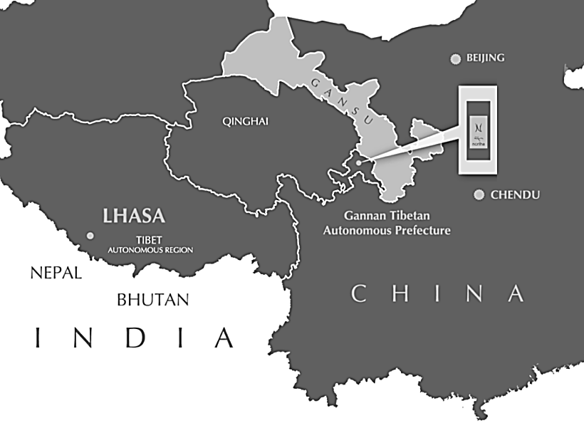

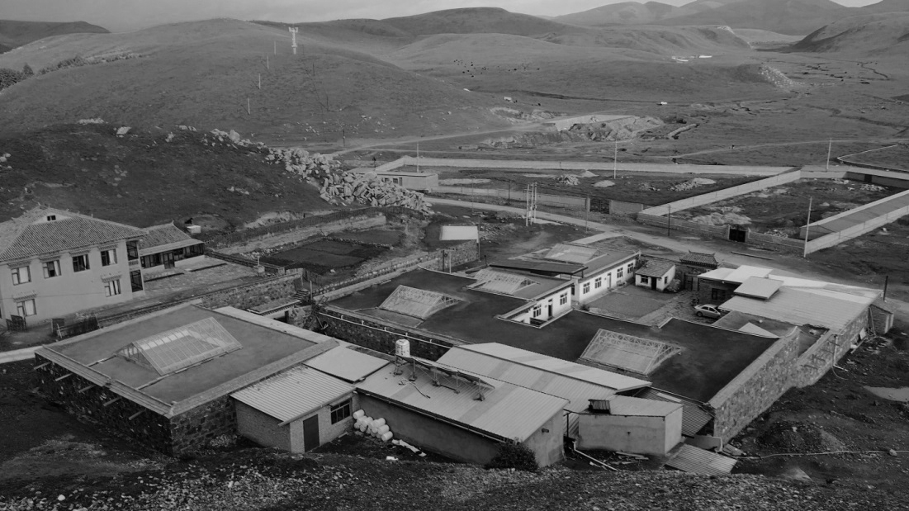

Photo source: Case writer and company archive.

Exhibit 2: Norlha textiles’s Brand Image

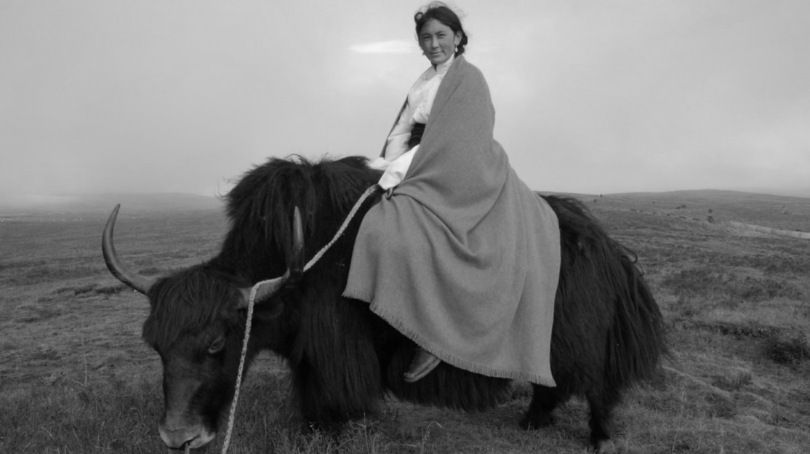



Photo source: Company archive.

Exhibit 3: Norlha’s Textile-Producing Process

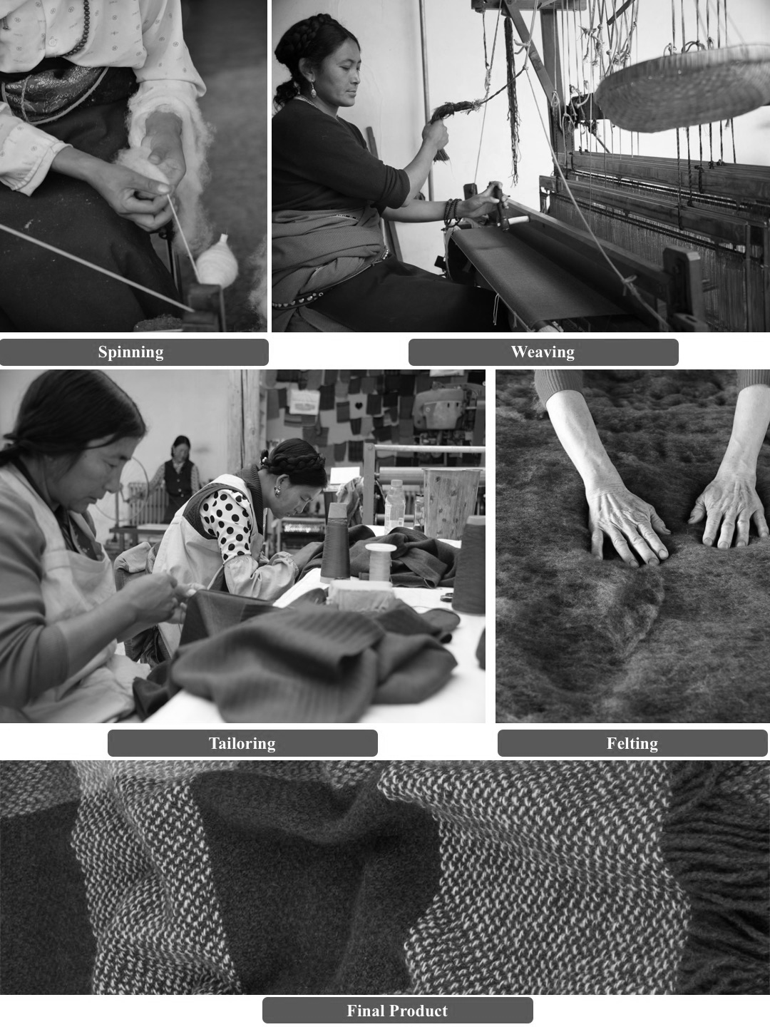

Photo source: Company archive.

Exhibit 4: 2015 monthly Wages at Norlha (in ¥)

|  |  |
| --- | --- |
| **Region** | **Average Per Capita Monthly Income** |
| China (Overall) | 1,038 |
| China (Urban) | 1,611 |
| China (Rural) | 383 |
| Beijing (Urban) | 2,714 |
| Gansu Province, China (Rural) | 578 |
| Gansu Province (Urban) | 1,980 |
| **Norlha** | **3,290** |

Note: ¥ = RMB = Chinese renminbi; US$1 = ¥6.25 and ¥1 = US$0.16 in 2015.

Source: Created by the case authors based on company archive; National Bureau of Statistics of the People’s Republic of China [In Chinese], accessed February 15, 2018, http://data.stats.gov.cn/; Gansu Province Bureau of Statistics [In Chinese], accessed February 15, 2018, www.gstj.gov.cn/; Beijing Bureau of Statistics [In Chinese], accessed February 15, 2018, www.bjstats.gov.cn.

Exhibit 5: Norlha’s Sales TrendS, 2014 Versus 2015 (In Percentages)

Exhibit 5 (continued)

Note: B2B = business-to-business

Source: Created by the case authors using company data.

Exhibit 6: Norlha textiles’s Income StatementS, 2013–2015 (in ¥)

|  |  |  |  |
| --- | --- | --- | --- |
|  | **2013** | **2014** | **2015** |
| **Sales Revenue** | **7,326,408** | **5,683,626** | **7,883,413** |
| Raw materials | 2,501,463 | 1,809,245 | 2,680,360 |
| Wages & Benefits (Production) | 1,065,098 | 1,396,380 | 1,421,406 |
| **Total Cost of goods sold** | **3,566,561** | **3,205,625** | **4,101,766** |
| Admin Salaries & Benefits (SG&A) | 404,570 | 684,217 | 817,300 |
| Beijing Office | 1,225,193 | 1,115,450 | 690,850 |
| Running Costs | 425,599 | 420,040 | 333,276 |
| International Business Development | 909,715 | 922,451 | 1,349,973 |
| Depreciation and Amortization Expense | 185,888 | 241,315 | 263,075 |
| **Total Operating Expenses** | **3,150,965** | **3,383,473** | **3,454,474** |
| **Operating profit** | **608,882** | **(905,472)** | **327,173** |
| Interest & other financial cost | 166,265 | 320,107 | 462,767 |
| Tax (VAT) | 29,885 | 54,798 | 109,585 |
| VAT refund | – | – | – |
| **Net income** | **412,733** | **(1,280,376)** | **(245,179)** |

Note: ¥ = RMB = Chinese renminbi; US$1 = ¥6.25 and ¥1 = US$0.16 in 2015; SG&A = selling, general, and administrative expenses; VAT = value added tax. The account of International Business Development included the expenses incurred for Norlha services through the Hong Kong parent company and foreign travel expenses for international business development in Europe and the United States.

Source: Created by the case authors using company data.

Exhibit 7: Current Market Landscape of the Yak Wool Business

|  |  |  |  |  |  |  |
| --- | --- | --- | --- | --- | --- | --- |
| **Brand** | **Location** | **Year of Established** | **Segment** | **Scarf Price (US$)** | **Major Markets** | **Company Description** |
| Norlha  www.norlhatextiles.com | Tibetan Plateau, China | 2007 | Luxury | $300–$600 | Mainland China, Europe, United States | Dechen Yeshi and her family created Norlha in 2007 with the mission to help Tibetan nomads to adapt to the fast-changing modern world while preserving their traditional landscape and culture. |
| Shokay  www.shokay.com | Shanghai, China | 2006 | Fashion | $50–$300 | Mainland China, Taiwan, United States | Shokay was founded in 2006 by Carol Chyau, a graduate of The Wharton School (University of Pennsylvania) and Harvard Kennedy School (Harvard University). By the end of 2013, the core team comprised 20 persons, and 50+ knitters from Shanghai. Shokay could be found around the world in more than 100 stores in 10 countries. |
| Khunu  www.khunu.com | United Kingdom | NA | Fashion &  Luxury | $100–$700 | Europe | The idea of Khunu was first developed during a bitterly cold mid-December trip to the Tibetan Plateau, where China-based expatriate Julian Wilson learned from herders how they kept warm in winter. Khunu had manufacturing partners in China, Italy, and the United Kingdom. |
| mYak  www.myak.it/en | Italy | 2011 | Fashion | $200–$300 | Europe | Born on the Tibetan Plateau and crafted in Italy, mYak was founded by Paola Vanzo and Andrea Dominici, with the help of Trace Foundation, a U.S. non-for-profit organization that supported the continuity, development, and vitality of Tibetan communities in China. mYak produces and sells yarns from the softest undercoat of yak and cashmere goats sourced from Tibetan nomads. |

Note: NA = not applicable

Source: Case authors using data from official websites.

1. Xuefeng Cui and Hans-F. Graf, “Recent Land Cover Changes on the Tibetan Plateau: A Review,” *Climatic Change* 94, no. 1–2 (2009): 47–61.
2. Fahu H. Chen, Guanghui H. Dong, Dongju J. Zhang, Xinyl Y. Liu, Xin Jia, Cheng-Bang An, et al., “Agriculture Facilitated Permanent Human Occupation of the Tibetan Plateau after 3600 BP,” *Science* 347, no. 6219 (2015): 248–250.
3. The Han people were the Chinese ethnic majority.
4. Melvyn Goldstein and Cynthia Beall, Nomads of Western Tibet: The Survival of a Way of Life (Berkeley, CA: University of California Press, 1990).
5. Terroir was a French concept that considered land from the point of view of its local environment, water, animal breeds, seeds, climate, sunlight, and its social and cultural attributes.
6. Case writer interview, June 4, 2017.
7. “Norlha, a Workshop on the Roof of the World,” Paris 1.618, accessed February 15, 2018, http://guide.1618-paris.com/selection-norlha and www.1618-paris.com/norlha/?lang=en.
8. For most formal organizations in the village, including the school and government, the working language was Mandarin.
9. ¥ = RMB = Chinese renminbi; all currency amounts are in ¥ unless otherwise specified; US$1 = ¥6.25 and ¥1 = US$0.16 in 2015.
10. In China, it took nine years after the first year in primary school to complete middle school.
11. “B.C. First Nation Takes on Ralph Lauren over Knockoff Sweaters,” CTV News, February 7, 2015, accessed March 31, 2018, www.ctvnews.ca/canada/b-c-first-nation-takes-on-ralph-lauren-over-knockoff-sweaters-1.2225767.
12. Zhibo Lin, “The Lessons We Learnt in Solving the Niba-Jiangcun Incident” [in Chinese], *People’s Daily* (online), November 1, 2014, accessed February 15, 2018, http://gs.people.com.cn/n/2014/1101/c183343-22780540.html.